> setwd("/media/user/软件/learnSpector/Bayes rules/260615shelly")
> running<-read_csv("agree0622.csv")
Rows: 26 Columns: 3
── Column specification ────────────────────────────────────────────────
Delimiter: ","
dbl (3): runner, age, net

ℹ Use `spec()` to retrieve the full column specification for this data.
ℹ Specify the column types or set `show_col_types = FALSE` to quiet this message.
> running_model_1_prior <- stan_glmer(
+ net ~ age + (1 | runner),
+ data = running, family = gaussian,
+ prior_intercept = normal(6.95, 3.01),
+ prior = normal(-1.7, 0.52),
+ prior_aux = exponential(1, autoscale = TRUE),
+ prior_covariance = decov(reg = 1, conc = 1, shape = 1, scale = 1),
+ chains = 4, iter = 5000*2, seed = 84735,
+ prior_PD = TRUE)

SAMPLING FOR MODEL 'continuous' NOW (CHAIN 1).
Chain 1:
Chain 1: Gradient evaluation took 0.000193 seconds
Chain 1: 1000 transitions using 10 leapfrog steps per transition would take 1.93 seconds.
Chain 1: Adjust your expectations accordingly!
Chain 1:
Chain 1:
Chain 1: Iteration: 1 / 10000 [ 0%] (Warmup)
Chain 1: Iteration: 1000 / 10000 [ 10%] (Warmup)
Chain 1: Iteration: 2000 / 10000 [ 20%] (Warmup)
Chain 1: Iteration: 3000 / 10000 [ 30%] (Warmup)
Chain 1: Iteration: 4000 / 10000 [ 40%] (Warmup)
Chain 1: Iteration: 5000 / 10000 [ 50%] (Warmup)
Chain 1: Iteration: 5001 / 10000 [ 50%] (Sampling)
Chain 1: Iteration: 6000 / 10000 [ 60%] (Sampling)
Chain 1: Iteration: 7000 / 10000 [ 70%] (Sampling)
Chain 1: Iteration: 8000 / 10000 [ 80%] (Sampling)
Chain 1: Iteration: 9000 / 10000 [ 90%] (Sampling)
Chain 1: Iteration: 10000 / 10000 [100%] (Sampling)
Chain 1:
Chain 1: Elapsed Time: 0.343566 seconds (Warm-up)
Chain 1: 0.431931 seconds (Sampling)
Chain 1: 0.775497 seconds (Total)
Chain 1:

SAMPLING FOR MODEL 'continuous' NOW (CHAIN 2).
Chain 2:
Chain 2: Gradient evaluation took 2.5e-05 seconds
Chain 2: 1000 transitions using 10 leapfrog steps per transition would take 0.25 seconds.
Chain 2: Adjust your expectations accordingly!
Chain 2:
Chain 2:
Chain 2: Iteration: 1 / 10000 [ 0%] (Warmup)
Chain 2: Iteration: 1000 / 10000 [ 10%] (Warmup)
Chain 2: Iteration: 2000 / 10000 [ 20%] (Warmup)
Chain 2: Iteration: 3000 / 10000 [ 30%] (Warmup)
Chain 2: Iteration: 4000 / 10000 [ 40%] (Warmup)
Chain 2: Iteration: 5000 / 10000 [ 50%] (Warmup)
Chain 2: Iteration: 5001 / 10000 [ 50%] (Sampling)
Chain 2: Iteration: 6000 / 10000 [ 60%] (Sampling)
Chain 2: Iteration: 7000 / 10000 [ 70%] (Sampling)
Chain 2: Iteration: 8000 / 10000 [ 80%] (Sampling)
Chain 2: Iteration: 9000 / 10000 [ 90%] (Sampling)
Chain 2: Iteration: 10000 / 10000 [100%] (Sampling)
Chain 2:
Chain 2: Elapsed Time: 0.324561 seconds (Warm-up)
Chain 2: 0.327714 seconds (Sampling)
Chain 2: 0.652275 seconds (Total)
Chain 2:

SAMPLING FOR MODEL 'continuous' NOW (CHAIN 3).
Chain 3:
Chain 3: Gradient evaluation took 2.5e-05 seconds
Chain 3: 1000 transitions using 10 leapfrog steps per transition would take 0.25 seconds.
Chain 3: Adjust your expectations accordingly!
Chain 3:
Chain 3:
Chain 3: Iteration: 1 / 10000 [ 0%] (Warmup)
Chain 3: Iteration: 1000 / 10000 [ 10%] (Warmup)
Chain 3: Iteration: 2000 / 10000 [ 20%] (Warmup)
Chain 3: Iteration: 3000 / 10000 [ 30%] (Warmup)
Chain 3: Iteration: 4000 / 10000 [ 40%] (Warmup)
Chain 3: Iteration: 5000 / 10000 [ 50%] (Warmup)
Chain 3: Iteration: 5001 / 10000 [ 50%] (Sampling)
Chain 3: Iteration: 6000 / 10000 [ 60%] (Sampling)
Chain 3: Iteration: 7000 / 10000 [ 70%] (Sampling)
Chain 3: Iteration: 8000 / 10000 [ 80%] (Sampling)
Chain 3: Iteration: 9000 / 10000 [ 90%] (Sampling)
Chain 3: Iteration: 10000 / 10000 [100%] (Sampling)
Chain 3:
Chain 3: Elapsed Time: 0.349505 seconds (Warm-up)
Chain 3: 0.371604 seconds (Sampling)
Chain 3: 0.721109 seconds (Total)
Chain 3:

SAMPLING FOR MODEL 'continuous' NOW (CHAIN 4).
Chain 4:
Chain 4: Gradient evaluation took 2.1e-05 seconds
Chain 4: 1000 transitions using 10 leapfrog steps per transition would take 0.21 seconds.
Chain 4: Adjust your expectations accordingly!
Chain 4:
Chain 4:
Chain 4: Iteration: 1 / 10000 [ 0%] (Warmup)
Chain 4: Iteration: 1000 / 10000 [ 10%] (Warmup)
Chain 4: Iteration: 2000 / 10000 [ 20%] (Warmup)
Chain 4: Iteration: 3000 / 10000 [ 30%] (Warmup)
Chain 4: Iteration: 4000 / 10000 [ 40%] (Warmup)
Chain 4: Iteration: 5000 / 10000 [ 50%] (Warmup)
Chain 4: Iteration: 5001 / 10000 [ 50%] (Sampling)
Chain 4: Iteration: 6000 / 10000 [ 60%] (Sampling)
Chain 4: Iteration: 7000 / 10000 [ 70%] (Sampling)
Chain 4: Iteration: 8000 / 10000 [ 80%] (Sampling)
Chain 4: Iteration: 9000 / 10000 [ 90%] (Sampling)
Chain 4: Iteration: 10000 / 10000 [100%] (Sampling)
Chain 4:
Chain 4: Elapsed Time: 0.342895 seconds (Warm-up)
Chain 4: 0.353971 seconds (Sampling)
Chain 4: 0.696866 seconds (Total)
Chain 4:
> set.seed(84735)
> running %>%
+ add_fitted_draws(running_model_1_prior, n = 4) %>%
+ ggplot(aes(x = age, y = net)) +
+ geom_line(aes(y = .value, group = paste(runner, .draw))) +
+ facet_wrap(~ .draw)
Warning message:
`fitted_draws` and `add_fitted_draws` are deprecated as their names were confusing.
- Use [add_]epred_draws() to get the expectation of the posterior predictive.
- Use [add_]linpred_draws() to get the distribution of the linear predictor.
- For example, you used [add_]fitted_draws(..., scale = "response"), which
means you most likely want [add_]epred_draws(...).
NOTE: When updating to the new functions, note that the `model` parameter is now
named `object` and the `n` parameter is now named `ndraws`.

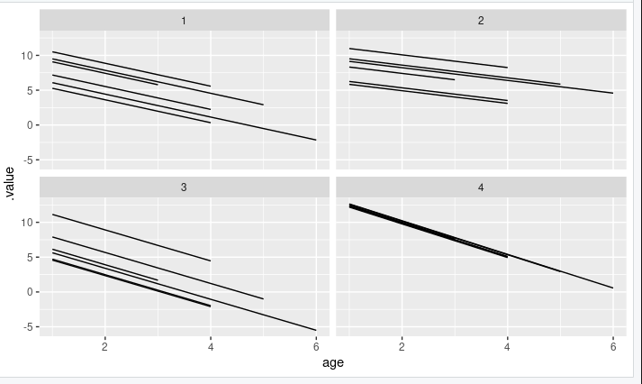

> set.seed(84735)
> running %>%
+ add_fitted_draws(running_model_1_prior, n = 4) %>%
+ ggplot(aes(x = age, y = net)) +
+ geom_line(aes(y = .value, group = paste(runner, .draw))) +
+ facet_wrap(~ .draw)
Warning message:
`fitted_draws` and `add_fitted_draws` are deprecated as their names were confusing.
- Use [add_]epred_draws() to get the expectation of the posterior predictive.
- Use [add_]linpred_draws() to get the distribution of the linear predictor.
- For example, you used [add_]fitted_draws(..., scale = "response"), which
means you most likely want [add_]epred_draws(...).
NOTE: When updating to the new functions, note that the `model` parameter is now
named `object` and the `n` parameter is now named `ndraws`.

> running %>%
+ add_predicted_draws(running_model_1_prior, n = 100) %>%
+ ggplot(aes(x = net)) +
+ geom_density(aes(x = .prediction, group = .draw)) +
+ xlim(-100,300)
Warning message:

In add_predicted_draws(): The `n` argument is a deprecated alias for `ndraws`.
Use the `ndraws` argument instead.
See help("tidybayes-deprecated").

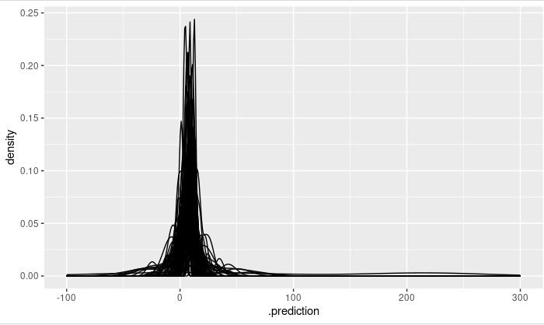

> ggplot(running, aes(x = age, y = net)) +
+ geom_point() +
+ facet_wrap(~ runner)

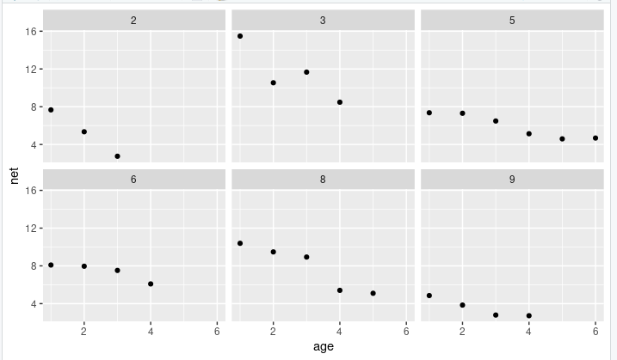

> # Simulate the posterior
> running_model_1 <- update(running_model_1_prior, prior_PD = FALSE)

SAMPLING FOR MODEL 'continuous' NOW (CHAIN 1).
Chain 1:
Chain 1: Gradient evaluation took 6.1e-05 seconds
Chain 1: 1000 transitions using 10 leapfrog steps per transition would take 0.61 seconds.
Chain 1: Adjust your expectations accordingly!
Chain 1:
Chain 1:
Chain 1: Iteration: 1 / 10000 [ 0%] (Warmup)
Chain 1: Iteration: 1000 / 10000 [ 10%] (Warmup)
Chain 1: Iteration: 2000 / 10000 [ 20%] (Warmup)
Chain 1: Iteration: 3000 / 10000 [ 30%] (Warmup)
Chain 1: Iteration: 4000 / 10000 [ 40%] (Warmup)
Chain 1: Iteration: 5000 / 10000 [ 50%] (Warmup)
Chain 1: Iteration: 5001 / 10000 [ 50%] (Sampling)
Chain 1: Iteration: 6000 / 10000 [ 60%] (Sampling)
Chain 1: Iteration: 7000 / 10000 [ 70%] (Sampling)
Chain 1: Iteration: 8000 / 10000 [ 80%] (Sampling)
Chain 1: Iteration: 9000 / 10000 [ 90%] (Sampling)
Chain 1: Iteration: 10000 / 10000 [100%] (Sampling)
Chain 1:
Chain 1: Elapsed Time: 1.54493 seconds (Warm-up)
Chain 1: 1.57254 seconds (Sampling)
Chain 1: 3.11747 seconds (Total)
Chain 1:

SAMPLING FOR MODEL 'continuous' NOW (CHAIN 2).
Chain 2:
Chain 2: Gradient evaluation took 2.9e-05 seconds
Chain 2: 1000 transitions using 10 leapfrog steps per transition would take 0.29 seconds.
Chain 2: Adjust your expectations accordingly!
Chain 2:
Chain 2:
Chain 2: Iteration: 1 / 10000 [ 0%] (Warmup)
Chain 2: Iteration: 1000 / 10000 [ 10%] (Warmup)
Chain 2: Iteration: 2000 / 10000 [ 20%] (Warmup)
Chain 2: Iteration: 3000 / 10000 [ 30%] (Warmup)
Chain 2: Iteration: 4000 / 10000 [ 40%] (Warmup)
Chain 2: Iteration: 5000 / 10000 [ 50%] (Warmup)
Chain 2: Iteration: 5001 / 10000 [ 50%] (Sampling)
Chain 2: Iteration: 6000 / 10000 [ 60%] (Sampling)
Chain 2: Iteration: 7000 / 10000 [ 70%] (Sampling)
Chain 2: Iteration: 8000 / 10000 [ 80%] (Sampling)
Chain 2: Iteration: 9000 / 10000 [ 90%] (Sampling)
Chain 2: Iteration: 10000 / 10000 [100%] (Sampling)
Chain 2:
Chain 2: Elapsed Time: 1.5772 seconds (Warm-up)
Chain 2: 1.61173 seconds (Sampling)
Chain 2: 3.18894 seconds (Total)
Chain 2:

SAMPLING FOR MODEL 'continuous' NOW (CHAIN 3).
Chain 3:
Chain 3: Gradient evaluation took 2.9e-05 seconds
Chain 3: 1000 transitions using 10 leapfrog steps per transition would take 0.29 seconds.
Chain 3: Adjust your expectations accordingly!
Chain 3:
Chain 3:
Chain 3: Iteration: 1 / 10000 [ 0%] (Warmup)
Chain 3: Iteration: 1000 / 10000 [ 10%] (Warmup)
Chain 3: Iteration: 2000 / 10000 [ 20%] (Warmup)
Chain 3: Iteration: 3000 / 10000 [ 30%] (Warmup)
Chain 3: Iteration: 4000 / 10000 [ 40%] (Warmup)
Chain 3: Iteration: 5000 / 10000 [ 50%] (Warmup)
Chain 3: Iteration: 5001 / 10000 [ 50%] (Sampling)
Chain 3: Iteration: 6000 / 10000 [ 60%] (Sampling)
Chain 3: Iteration: 7000 / 10000 [ 70%] (Sampling)
Chain 3: Iteration: 8000 / 10000 [ 80%] (Sampling)
Chain 3: Iteration: 9000 / 10000 [ 90%] (Sampling)
Chain 3: Iteration: 10000 / 10000 [100%] (Sampling)
Chain 3:
Chain 3: Elapsed Time: 1.51111 seconds (Warm-up)
Chain 3: 1.96978 seconds (Sampling)
Chain 3: 3.48089 seconds (Total)
Chain 3:

SAMPLING FOR MODEL 'continuous' NOW (CHAIN 4).
Chain 4:
Chain 4: Gradient evaluation took 2.9e-05 seconds
Chain 4: 1000 transitions using 10 leapfrog steps per transition would take 0.29 seconds.
Chain 4: Adjust your expectations accordingly!
Chain 4:
Chain 4:
Chain 4: Iteration: 1 / 10000 [ 0%] (Warmup)
Chain 4: Iteration: 1000 / 10000 [ 10%] (Warmup)
Chain 4: Iteration: 2000 / 10000 [ 20%] (Warmup)
Chain 4: Iteration: 3000 / 10000 [ 30%] (Warmup)
Chain 4: Iteration: 4000 / 10000 [ 40%] (Warmup)
Chain 4: Iteration: 5000 / 10000 [ 50%] (Warmup)
Chain 4: Iteration: 5001 / 10000 [ 50%] (Sampling)
Chain 4: Iteration: 6000 / 10000 [ 60%] (Sampling)
Chain 4: Iteration: 7000 / 10000 [ 70%] (Sampling)
Chain 4: Iteration: 8000 / 10000 [ 80%] (Sampling)
Chain 4: Iteration: 9000 / 10000 [ 90%] (Sampling)
Chain 4: Iteration: 10000 / 10000 [100%] (Sampling)
Chain 4:
Chain 4: Elapsed Time: 1.43769 seconds (Warm-up)
Chain 4: 1.30657 seconds (Sampling)
Chain 4: 2.74426 seconds (Total)
Chain 4:
> # Check the prior specifications
> prior_summary(running_model_1)
Priors for model 'running_model_1'
------
Intercept (after predictors centered)
~ normal(location = 7, scale = 3)

Coefficients
~ normal(location = -1.7, scale = 0.52)

Auxiliary (sigma)
Specified prior:
~ exponential(rate = 1)
Adjusted prior:
~ exponential(rate = 0.33)

Covariance
~ decov(reg. = 1, conc. = 1, shape = 1, scale = 1)
------
See help('prior_summary.stanreg') for more details
> # Markov chain diagnostics
> mcmc_trace(running_model_1)
Warning message:
Using `size` aesthetic for lines was deprecated in ggplot2 3.4.0.
ℹ Please use `linewidth` instead.
ℹ The deprecated feature was likely used in the bayesplot package.
Please report the issue at
<https://github.com/stan-dev/bayesplot/issues/>.
This warning is displayed once every 8 hours.
Call `lifecycle::last_lifecycle_warnings()` to see where this warning
was generated.

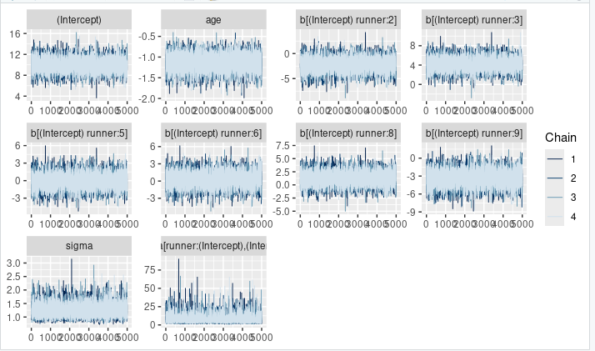

> mcmc_dens_overlay(running_model_1)

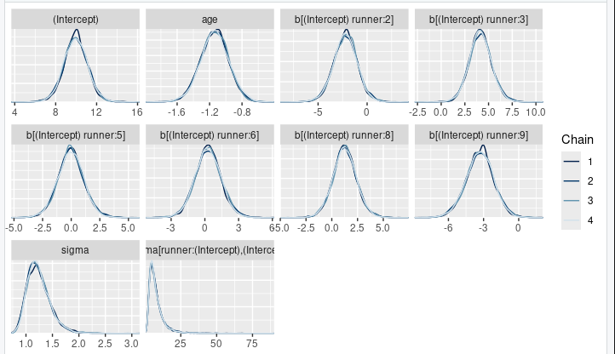

neff_ratio(running_model_1)
(Intercept)
0.27565
age
0.78720
b[(Intercept) runner:2]
0.30810
b[(Intercept) runner:3]
0.30165
b[(Intercept) runner:5]
0.27885
b[(Intercept) runner:6]
0.29550
b[(Intercept) runner:8]
0.28840
b[(Intercept) runner:9]
0.30465
sigma
0.47685
Sigma[runner:(Intercept),(Intercept)]
0.39345
> rhat(running_model_1)
(Intercept)
1.000534
age
1.000175
b[(Intercept) runner:2]
1.000620
b[(Intercept) runner:3]
1.000707
b[(Intercept) runner:5]
1.000738
b[(Intercept) runner:6]
1.000625
b[(Intercept) runner:8]
1.000539
b[(Intercept) runner:9]
1.000790
sigma
1.000342
Sigma[runner:(Intercept),(Intercept)]
1.000103
> tidy_summary_1 <- tidy(running_model_1, effects = "fixed",
+ conf.int = TRUE, conf.level = 0.80)
> tidy_summary_1
# A tibble: 2 × 5
term estimate std.error conf.low conf.high
<chr> <dbl> <dbl> <dbl> <dbl>
1 (Intercept) 9.96 1.13 8.50 11.4
2 age -1.14 0.171 -1.36 -0.919
> B0 <- tidy_summary_1$estimate[1]
> B1 <- tidy_summary_1$estimate[2]
> running %>%
+ add_fitted_draws(running_model_1, n = 200, re_formula = NA) %>%
+ ggplot(aes(x = age, y = net)) +
+ geom_line(aes(y = .value, group = .draw), alpha = 0.1) +
+ geom_abline(intercept = B0, slope = B1, color = "blue") +
+ lims(y = c(75, 110))
Warning messages:
1: `fitted_draws` and `add_fitted_draws` are deprecated as their names were confusing.
- Use [add_]epred_draws() to get the expectation of the posterior predictive.
- Use [add_]linpred_draws() to get the distribution of the linear predictor.
- For example, you used [add_]fitted_draws(..., scale = "response"), which
means you most likely want [add_]epred_draws(...).
NOTE: When updating to the new functions, note that the `model` parameter is now
named `object` and the `n` parameter is now named `ndraws`.
2: Removed 5200 rows containing missing values or values outside the scale
range (`geom_line()`).
> # Posterior summaries of runner-specific intercepts
> runner_summaries_1 <- running_model_1 %>%
+ spread_draws(`(Intercept)`, b[,runner]) %>%
+ mutate(runner_intercept = `(Intercept)` + b) %>%
+ select(-`(Intercept)`, -b) %>%
+ median_qi(.width = 0.80) %>%
+ select(runner, runner_intercept, .lower, .upper)
> runner_summaries_1 %>%
+ filter(runner %in% c("runner:4", "runner:5"))
# A tibble: 1 × 4
runner runner_intercept .lower .upper
<chr> <dbl> <dbl> <dbl>
1 runner:5 9.91 8.93 10.9
> # 100 posterior plausible models for runners 4 & 5
> running %>%
+ filter(runner %in% c("4", "5")) %>%
+ add_fitted_draws(running_model_1, n = 100) %>%
+ ggplot(aes(x = age, y = net)) +
+ geom_line(
+ aes(y = .value, group = paste(runner, .draw), color = runner),
+ alpha = 0.1) +
+ geom_point(aes(color = runner))
Warning message:
`fitted_draws` and `add_fitted_draws` are deprecated as their names were confusing.
- Use [add_]epred_draws() to get the expectation of the posterior predictive.
- Use [add_]linpred_draws() to get the distribution of the linear predictor.
- For example, you used [add_]fitted_draws(..., scale = "response"), which
means you most likely want [add_]epred_draws(...).
NOTE: When updating to the new functions, note that the `model` parameter is now
named `object` and the `n` parameter is now named `ndraws`.

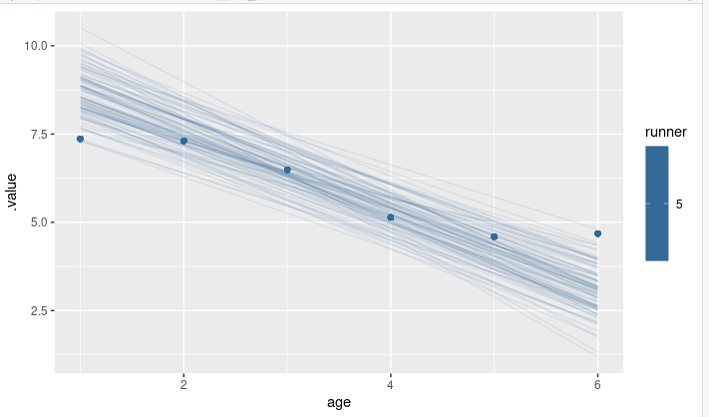

> # Plot runner-specific models with the global model
> ggplot(running, aes(y = net, x = age, group = runner)) +
+ geom_abline(data = runner_summaries_1, color = "gray",
+ aes(intercept = runner_intercept, slope = B1)) +
+ geom_abline(intercept = B0, slope = B1, color = "blue") +
+ lims(x = c(1, 6), y = c(0, 0.8))

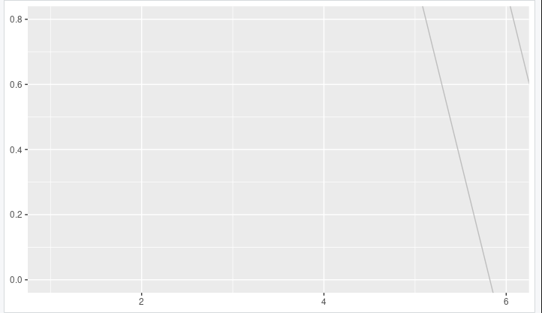

tidy_sigma <- tidy(running_model_1, effects = "ran_pars")
> tidy_sigma
# A tibble: 2 × 3
term group estimate
<chr> <chr> <dbl>
1 sd_(Intercept).runner runner 2.79
2 sd_Observation.Residual Residual 1.24
> sigma_0 <- tidy_sigma[1,3]
> sigma_y <- tidy_sigma[2,3]
> sigma_0^2 / (sigma_0^2 + sigma_y^2)
estimate
1 0.8346638
>
> sigma_y^2 / (sigma_0^2 + sigma_y^2)
estimate
1 0.1653362
> # Plot runner-specific models in the data
> running %>%
+ filter(runner %in% c("4", "5", "20", "29")) %>%
+ ggplot(., aes(x = age, y = net)) +
+ geom_point() +
+ geom_smooth(method = "lm", se = FALSE) +
+ facet_grid(~ runner)
`geom_smooth()` using formula = 'y ~ x'

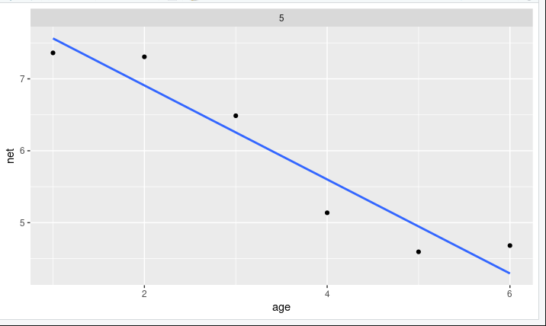

ggplot(running, aes(x = age, y = net, group = runner)) +
+ geom_smooth(method = "lm", se = FALSE, size = 0.5)
`geom_smooth()` using formula = 'y ~ x'

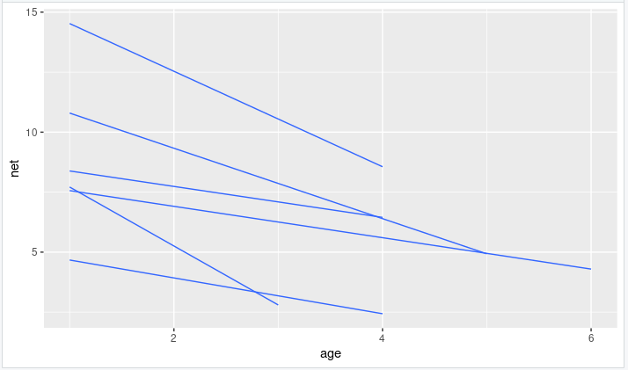

> running_model_2 <- stan_glmer(
+ net ~ age + (age | runner),
+ data = running, family = gaussian,
+ prior_intercept = normal(100, 10),
+ prior = normal(2.5, 1),
+ prior_aux = exponential(1, autoscale = TRUE),
+ prior_covariance = decov(reg = 1, conc = 1, shape = 1, scale = 1),
+ chains = 4, iter = 5000*2, seed = 84735, adapt_delta = 0.99999
+ )

SAMPLING FOR MODEL 'continuous' NOW (CHAIN 1).
Chain 1:
Chain 1: Gradient evaluation took 8.4e-05 seconds
Chain 1: 1000 transitions using 10 leapfrog steps per transition would take 0.84 seconds.
Chain 1: Adjust your expectations accordingly!
Chain 1:
Chain 1:
Chain 1: Iteration: 1 / 10000 [ 0%] (Warmup)
Chain 1: Iteration: 1000 / 10000 [ 10%] (Warmup)
Chain 1: Iteration: 2000 / 10000 [ 20%] (Warmup)
Chain 1: Iteration: 3000 / 10000 [ 30%] (Warmup)
Chain 1: Iteration: 4000 / 10000 [ 40%] (Warmup)
Chain 1: Iteration: 5000 / 10000 [ 50%] (Warmup)
Chain 1: Iteration: 5001 / 10000 [ 50%] (Sampling)
Chain 1: Iteration: 6000 / 10000 [ 60%] (Sampling)
Chain 1: Iteration: 7000 / 10000 [ 70%] (Sampling)
Chain 1: Iteration: 8000 / 10000 [ 80%] (Sampling)
Chain 1: Iteration: 9000 / 10000 [ 90%] (Sampling)
Chain 1: Iteration: 10000 / 10000 [100%] (Sampling)
Chain 1:
Chain 1: Elapsed Time: 213.977 seconds (Warm-up)
Chain 1: 336.035 seconds (Sampling)
Chain 1: 550.012 seconds (Total)
Chain 1:

SAMPLING FOR MODEL 'continuous' NOW (CHAIN 2).
Chain 2:
Chain 2: Gradient evaluation took 4.8e-05 seconds
Chain 2: 1000 transitions using 10 leapfrog steps per transition would take 0.48 seconds.
Chain 2: Adjust your expectations accordingly!
Chain 2:
Chain 2:
Chain 2: Iteration: 1 / 10000 [ 0%] (Warmup)
Chain 2: Iteration: 1000 / 10000 [ 10%] (Warmup)
Chain 2: Iteration: 2000 / 10000 [ 20%] (Warmup)
Chain 2: Iteration: 3000 / 10000 [ 30%] (Warmup)
Chain 2: Iteration: 4000 / 10000 [ 40%] (Warmup)
Chain 2: Iteration: 5000 / 10000 [ 50%] (Warmup)
Chain 2: Iteration: 5001 / 10000 [ 50%] (Sampling)
Chain 2: Iteration: 6000 / 10000 [ 60%] (Sampling)
Chain 2: Iteration: 7000 / 10000 [ 70%] (Sampling)
Chain 2: Iteration: 8000 / 10000 [ 80%] (Sampling)
Chain 2: Iteration: 9000 / 10000 [ 90%] (Sampling)
Chain 2: Iteration: 10000 / 10000 [100%] (Sampling)
Chain 2:
Chain 2: Elapsed Time: 204.487 seconds (Warm-up)
Chain 2: 315.657 seconds (Sampling)
Chain 2: 520.144 seconds (Total)
Chain 2:

SAMPLING FOR MODEL 'continuous' NOW (CHAIN 3).
Chain 3:
Chain 3: Gradient evaluation took 5.3e-05 seconds
Chain 3: 1000 transitions using 10 leapfrog steps per transition would take 0.53 seconds.
Chain 3: Adjust your expectations accordingly!
Chain 3:
Chain 3:
Chain 3: Iteration: 1 / 10000 [ 0%] (Warmup)
Chain 3: Iteration: 1000 / 10000 [ 10%] (Warmup)
Chain 3: Iteration: 2000 / 10000 [ 20%] (Warmup)
Chain 3: Iteration: 3000 / 10000 [ 30%] (Warmup)
Chain 3: Iteration: 4000 / 10000 [ 40%] (Warmup)
Chain 3: Iteration: 5000 / 10000 [ 50%] (Warmup)
Chain 3: Iteration: 5001 / 10000 [ 50%] (Sampling)
Chain 3: Iteration: 6000 / 10000 [ 60%] (Sampling)
Chain 3: Iteration: 7000 / 10000 [ 70%] (Sampling)
Chain 3: Iteration: 8000 / 10000 [ 80%] (Sampling)
Chain 3: Iteration: 9000 / 10000 [ 90%] (Sampling)
Chain 3: Iteration: 10000 / 10000 [100%] (Sampling)
Chain 3:
Chain 3: Elapsed Time: 219.683 seconds (Warm-up)
Chain 3: 355.244 seconds (Sampling)
Chain 3: 574.927 seconds (Total)
Chain 3:

SAMPLING FOR MODEL 'continuous' NOW (CHAIN 4).
Chain 4:
Chain 4: Gradient evaluation took 7e-05 seconds
Chain 4: 1000 transitions using 10 leapfrog steps per transition would take 0.7 seconds.
Chain 4: Adjust your expectations accordingly!
Chain 4:
Chain 4:
Chain 4: Iteration: 1 / 10000 [ 0%] (Warmup)
Chain 4: Iteration: 1000 / 10000 [ 10%] (Warmup)
Chain 4: Iteration: 2000 / 10000 [ 20%] (Warmup)
Chain 4: Iteration: 3000 / 10000 [ 30%] (Warmup)
Chain 4: Iteration: 4000 / 10000 [ 40%] (Warmup)
Chain 4: Iteration: 5000 / 10000 [ 50%] (Warmup)
Chain 4: Iteration: 5001 / 10000 [ 50%] (Sampling)
Chain 4: Iteration: 6000 / 10000 [ 60%] (Sampling)
Chain 4: Iteration: 7000 / 10000 [ 70%] (Sampling)
Chain 4: Iteration: 8000 / 10000 [ 80%] (Sampling)
Chain 4: Iteration: 9000 / 10000 [ 90%] (Sampling)
Chain 4: Iteration: 10000 / 10000 [100%] (Sampling)
Chain 4:
Chain 4: Elapsed Time: 197.451 seconds (Warm-up)
Chain 4: 282.226 seconds (Sampling)
Chain 4: 479.677 seconds (Total)
Chain 4:

> # Confirm the prior model specifications
> prior_summary(running_model_2)
Priors for model 'running_model_2'
------
Intercept (after predictors centered)
~ normal(location = 100, scale = 10)

Coefficients
~ normal(location = 2.5, scale = 1)

Auxiliary (sigma)
Specified prior:
~ exponential(rate = 1)
Adjusted prior:
~ exponential(rate = 0.33)

Covariance
~ decov(reg. = 1, conc. = 1, shape = 1, scale = 1)
------
See help('prior_summary.stanreg') for more details
> # Quick summary of global regression parameters
> tidy(running_model_2, effects = "fixed", conf.int = TRUE, conf.level = 0.80)
# A tibble: 2 × 5
term estimate std.error conf.low conf.high
<chr> <dbl> <dbl> <dbl> <dbl>
1 (Intercept) 41.4 22.1 16.8 66.0
2 age 3.21 1.03 1.87 4.50
> # Get MCMC chains for the runner-specific intercepts & slopes
> runner_chains_2 <- running_model_2 %>%
+ spread_draws(`(Intercept)`, b[term, runner], `age`) %>%
+ pivot_wider(names_from = term, names_glue = "b_{term}",
+ values_from = b) %>%
+ mutate(runner_intercept = `(Intercept)` + `b_(Intercept)`,
+ runner_age = age + b_age)
> # Posterior medians of runner-specific models
> runner_summaries_2 <- runner_chains_2 %>%
+ group_by(runner) %>%
+ summarize(runner_intercept = median(runner_intercept),
+ runner_age = median(runner_age))
> # Check it out
> head(runner_summaries_2, 3)
# A tibble: 3 × 3
runner runner_intercept runner_age
<chr> <dbl> <dbl>
1 runner:2 9.40 -2.04
2 runner:3 15.5 -1.60
3 runner:5 8.70 -0.776
> ggplot(running, aes(y = net, x = age, group = runner)) +
+ geom_abline(data = runner_summaries_2, color = "gray",
+ aes(intercept = runner_intercept, slope = runner_age)) +
+ lims(x = c(1, 6), y = c(0, 0.8))
>

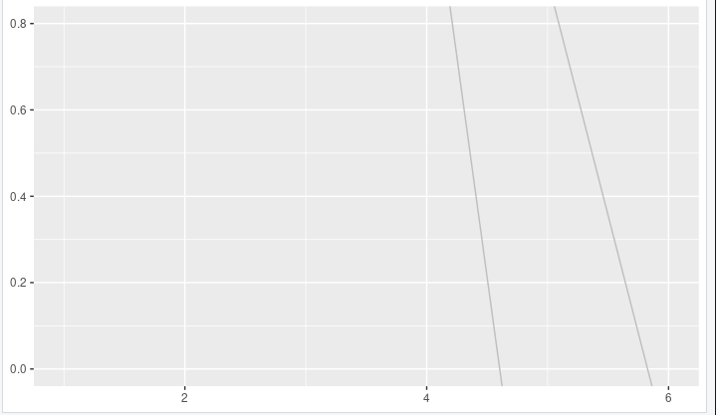

> runner_summaries_2 %>%
+ filter(runner %in% c("runner:1", "runner:10"))
# A tibble: 0 × 3
# ℹ 3 variables: runner <chr>, runner_intercept <dbl>, runner_age <dbl>
> tidy(running_model_2, effects = "ran_pars")
# A tibble: 4 × 3
term group estimate
<chr> <chr> <dbl>
1 sd_(Intercept).runner runner 22.0
2 sd_age.runner runner 3.62
3 cor_(Intercept).age.runner runner 0.648
4 sd_Observation.Residual Residual 1.52
> pp_check(running_model_1) +
+ labs(x = "net", title = "running model 1")

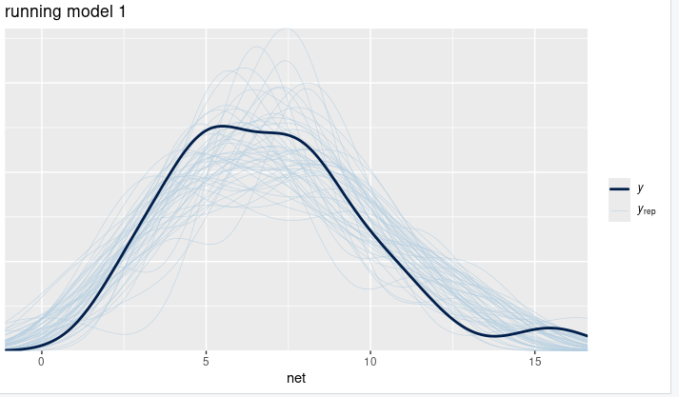

> pp_check(running_model_2) +
+ labs(x = "net", title = "running model 2")

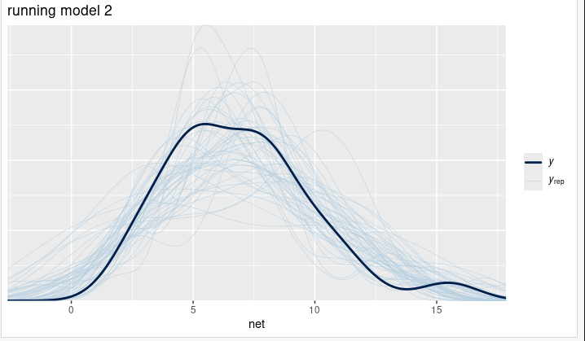

> # Calculate prediction summaries

> set.seed(84735)
> prediction_summary(model = running_model_1, data = running)
mae mae_scaled within_50 within_95
1 0.6378548 0.4417583 0.5769231 1
> prediction_summary(model = running_model_2, data = running)
mae mae_scaled within_50 within_95
1 0.4405255 0.2215375 0.8846154 1

> prediction_summary_cv(model = running_model_1, data = running,
+ k = 10, group = "runner")
Error in prediction_summary_cv(model = running_model_1, data = running, :
1 assertions failed:
* Variable 'data[[id_col]]': Must be of type 'factor', not
* 'double'.
> #Calculate ELPD for the 2 models
> elpd_hierarchical_1 <- loo(running_model_1)
Warning message:
Found 1 observation(s) with a pareto_k > 0.7. We recommend calling 'loo' again with argument 'k_threshold = 0.7' in order to calculate the ELPD without the assumption that these observations are negligible. This will refit the model 1 times to compute the ELPDs for the problematic observations directly.

> elpd_hierarchical_2 <- loo(running_model_2)
Warning message:
Found 2 observation(s) with a pareto_k > 0.7. We recommend calling 'loo' again with argument 'k_threshold = 0.7' in order to calculate the ELPD without the assumption that these observations are negligible. This will refit the model 2 times to compute the ELPDs for the problematic observations directly.

> # Compare the ELPD
> loo_compare(elpd_hierarchical_1, elpd_hierarchical_2)
elpd_diff se_diff
running_model_1 0.0 0.0
running_model_2 -1.9 2.4
> # Plot runner-specific trends for runners 1 & 10
> running %>%
+ filter(runner %in% c("6", "8")) %>%
+ ggplot(., aes(x = age, y = net)) +
+ geom_point() +
+ facet_grid(~ runner) +
+ lims(x = c(1, 8))

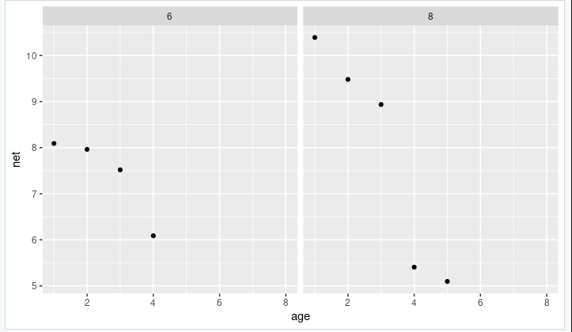

> set.seed(84735)
> predict_next_race <- posterior_predict(
+ running_model_1,
+ newdata = data.frame(runner = c("6", "P11", "8"),
+ age = c(5, 1,6)))
> B0 + B1 * 61
[1] -59.43895
>
>
>
> # Posterior predictive model plots
> mcmc_areas(predict_next_race, prob = 0.8) +
+ ggplot2::scale_y_discrete(labels = c("runner 6", "P11", "runner 8"))
Scale for y is already present.
Adding another scale for y, which will replace the existing scale.

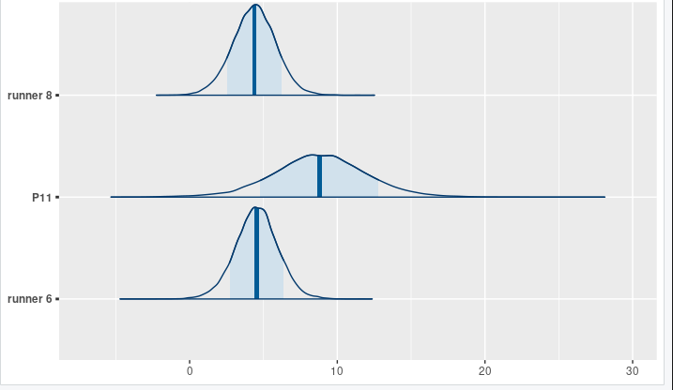

> # 计算每个选手的分位数
> quantiles <- apply(predict_next_race, 2, function(x) {
+ quantile(x, probs = c(0.25, 0.50, 0.75))
+ })
> # 将结果转换为更易读的格式
> quantiles_df <- as.data.frame(quantiles)
> colnames(quantiles_df) <- c("runner6", "P11", "runner8")
> rownames(quantiles_df) <- c("25%", "50%", "75%")
> # 显示结果
> print(quantiles_df)
runner6 P11 runner8
25% 3.610013 6.776206 3.418716
50% 4.543689 8.801566 4.386231
75% 5.469405 10.846482 5.349462

